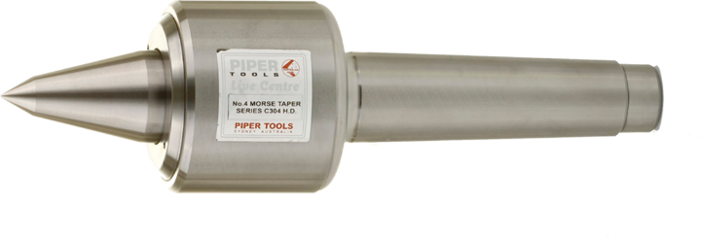

|  |  |  |  |  |  |  |  |  |  |  |  |  |  |  |
| --- | --- | --- | --- | --- | --- | --- | --- | --- | --- | --- | --- | --- | --- | --- |
| PIPER C SERIES – Heavy Duty Extended Cone | | | | | | | | | | | | | | |
| Model No. | Morse Taper No. | A mm | B mm | C mm | D mm | E mm | F mm | G mm | H mm | J mm | M mm | Load Carrying Capacity | Spindle Runout | Price |
| C-302-HD | **2** | 47 | 42 | 67 | 17.5 | 15 | 21 | 48 | 99 | 9 | 10 | 100kg | 3 Microns |  |
| C-303-HD | 3 | 47 | 51 | 80 | 24 | 20 | 25 | 60 | 89 | 12 | 10 | 200kg | 3 Microns |  |
| C-304-HD | 4 | 57 | 54 | 96 | 31 | 26 | 28 | 63 | 97 | 12.5 | 10 | 400kg | 3 Microns |  |
| C-305-HD | 5 | 64 | 71 | 118 | 44 | 38 | 43 | 95 | 136 | 18 | 13 | 1000kg | 3 Microns |  |
| C-306-HD | 6 | 97 | 95 | 187 | 63 | 54 | 60 | 105 | 209 | 27 | 19 | 6000kg | 5 Microns |  |

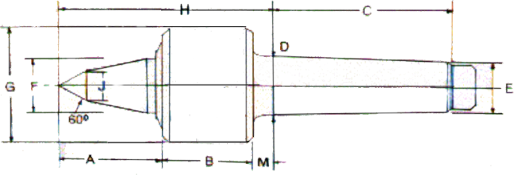

|  |  |  |  |  |  |  |  |  |  |  |  |  |  |
| --- | --- | --- | --- | --- | --- | --- | --- | --- | --- | --- | --- | --- | --- |
| PIPER R SERIES – Heavy Duty | | | | | | | | | | | | | |
| Model No. | Morse Taper No. | A mm | B mm | C mm | D mm | E mm | F mm | G mm | H mm | M mm | Load Carrying Capacity | Spindle Runout | Price |
| R-303-HD | 3 | 32 | 51 | 80 | 24 | 20 | 25 | 60 | 89 | 10 | 200kg | 3 Microns |  |
| R-304-HD | 4 | 36 | 54 | 96 | 31 | 26 | 28 | 63 | 97 | 10 | 635kg | 3 Microns |  |
| R-305-HD | 5 | 49 | 71 | 118 | 44 | 38 | 41.5 | 88 | 136 | 13 | 3000kg | 3 Microns |  |
| R-306-HD | 6 | 67 | 95 | 187 | 63 | 54 | 60 | 106 | 197 | 19 | 6000kg | 5 Microns |  |
| R-307-HD | 7 | 67 | 95 | 187 | 83 | 71 | 60 | 136 | 228 | 19 | 6000kg | 5 Microns |  |

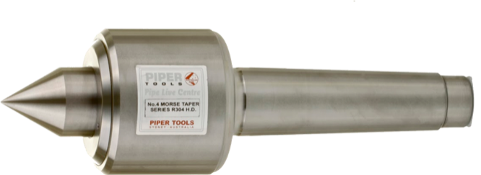

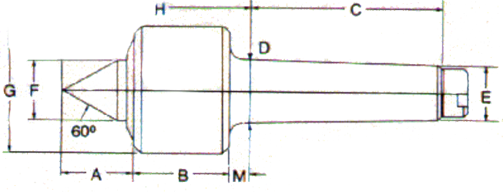

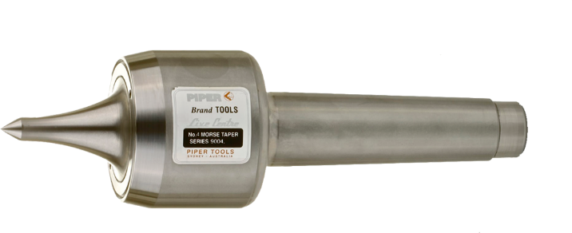

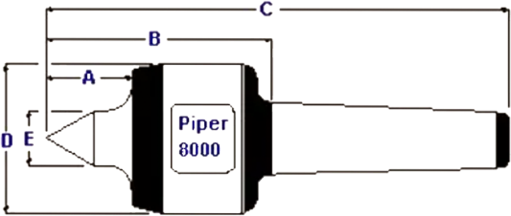

|  |  |  |  |  |  |  |  |  |  |  |
| --- | --- | --- | --- | --- | --- | --- | --- | --- | --- | --- |
| PIPER 8000 SERIES – High Speed | | | | | | | | | | |
| Model No. | Morse Taper | A mm | B mm | C mm | D mm | E mm | Max Work Piece Weight | Max Recommended Speed | Spindle Runout | Price |
| 8003 | 3 | 30 | 92 | 173 | 52 | 20 | 450kg | 9000RPM | 3 Microns |  |
| 8004 | 4 | 38 | 115 | 210 | 66 | 24 | 950kg | 7500RPM | 3 Microns |  |
| 8005 | 5 | 50 | 131 | 246 | 80 | 30 | 1500kg | 61 OORPM | 3 Microns |  |

|  |  |  |  |  |  |  |  |  |  |  |
| --- | --- | --- | --- | --- | --- | --- | --- | --- | --- | --- |
| PIPER 9000 SERIES – High Speed | | | | | | | | | | |
| Model No. | Morse Taper | A mm | B mm | C mm | D mm | E mm | Max Work Piece Weight | Max Recommended Speed | Spindle Runout | Price |
| 9003 | 3 | 40 | 92 | 173 | 52 | 8 | 350kg | 9000RPM | 3 Microns |  |
| 9004 | 4 | 50 | 115 | 210 | 66 | 10 | 700kg | 7500RPM | 3 Microns |  |
| 9005 | 5 | 60 | 131 | 246 | 80 | 12 | 1150kg | 6100RPM | 3 Microns |  |

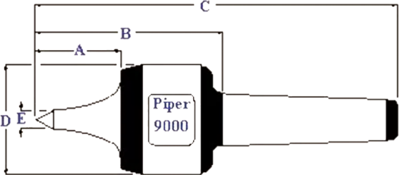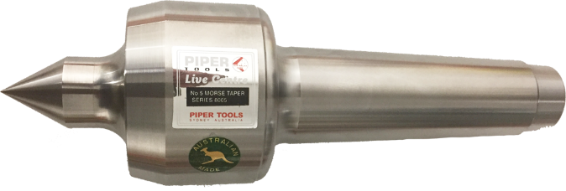

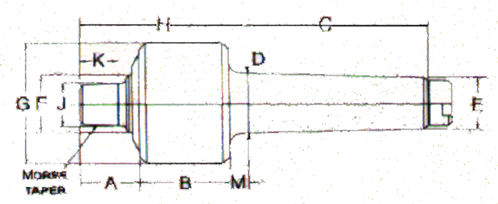

|  |  |  |  |  |  |  |  |  |  |  |  |  |  |  |
| --- | --- | --- | --- | --- | --- | --- | --- | --- | --- | --- | --- | --- | --- | --- |
| PIPER A SERIES (BODY) **PIPER TOOLS AUSTRALIA PTY LTD****2025 LIVE CENTRES** | | | | | | | | | | | | | | |
| Model No. | Morse Taper | A mm | B mm | C mm | D mm | E mm | F mm | G mm | H mm | J mm | M mm | Load Capacity | Spindle Runout | Price |
| A-402-HD | 2 | 33 | 44.5 | 62 | 18 | 15 | 21.5 | 49.5 | 83 | 21 | 8 | 170kgs | 3 microns |  |
| A-403-HD | 3 | 33 | 51 | 80 | 24 | 20 | 25 | 60 | 89 | 21 | 10 | 200kgs | 3 microns |  |
| A-404-HD | 4 | 3 | 54 | 96 | 31 | 26 | 28 | 63 | 97 | 21 | 10 | 635kgs | 3 microns |  |
| A-405-HD | 5 | 51 | 71 | 118 | 44 | 38 | 43 | 95 | 136 | 31 | 13 | 1500kgs | 3 microns |  |
| A-406-HD | 6 | 65 | 95 | 187 | 63 | 54 | 60 | 126 | 176 | 34 | 19 | 3000kg | 5 microns |  |

|  |  |  |  |  |  |  |  |  |  |  |  |  |  |
| --- | --- | --- | --- | --- | --- | --- | --- | --- | --- | --- | --- | --- | --- |
| PIPER B SERIES (CONE ONLY) | | | | | | | | | | | | | |
| Model No. | Morse Taper | A mm | B mm | C mm | D mm | E mm | F mm | G mm | H mm | J mm | M mm | Price |
| B-601 -HD | 2 | 44 | 30 | 62 | 18 | 15 | 83 | 51 | 83 | 21 | 8 |  |
| B-602-HD | 2 | 57 | 17 | 62 | 18 | 15 | 108 | 51 | 83 | 21 | 8 |  |
| B-601-HD | 3 | 44 | 36 | 76 | 24 | 20 | 83 | 60 | 90 | 21 | 10 |  |
| B-602-HD | 3 | 57 | 24 | 76 | 24 | 20 | 108 | 60 | 90 | 21 | 10 |  |
| B-607-HD | 3 | 78 | 3 | 76 | 24 | 20 | 159 | 60 | 90 | 21 | 10 |  |
| B-601-HD | 4 | 44 | 40 | 95 | 31 | 26 | 83 | 64 | 94 | 21 | 10 |  |
| B-602-HD | 4 | 57 | 27 | 95 | 31 | 26 | 108 | 64 | 94 | 21 | 10 |  |
| B-607-HD | 4 | 78 | 6 | 95 | 31 | 26 | 159 | 64 | 94 | 21 | 10 |  |
| B-608-HD | 5 | 64 | 59 | 121 | 44 | 38 | 133 | 95 | 135 | 38 | 13 |  |
| B-609-HD | 5 | 78 | 44 | 121 | 44 | 38 | 159 | 95 | 135 | 38 | 13 |  |
| B-610-HD | 5 | 103 | 19 | 121 | 44 | 38 | 210 | 95 | 135 | 38 | 13 |  |
| B-611-HD | 6 | 71 | 86 | 181 | 63 | 54 | 159 | 127 | 176 | 51 | 19 |  |
| B-612-HD | 6 | 98 | 59 | 181 | 63 | 54 | 210 | 127 | 176 | 51 | 19 |  |
| B-613-HD | 6 | 122 | 35 | 181 | 63 | 54 | 260 | 127 | 176 | 51 | 19 |  |

*Drawing with body and cone is for reference only 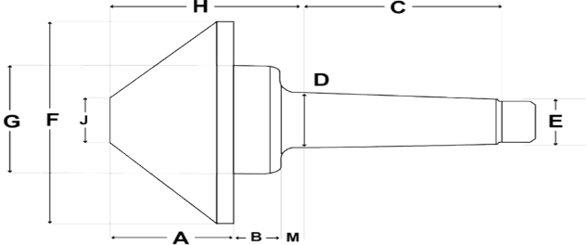

|  |  |  |  |  |  |  |  |  |
| --- | --- | --- | --- | --- | --- | --- | --- | --- |
| PIPER PL SERIES | | | | | | | | |
| Part No. | Morse Taper | D1 mm | D2 mm | L1 mm | L2 mm | L3 mm | L4 mm | Price |
| PL204/3 | 3 | 70 | 16 | 23 | 43 | 90 | 108 |  |
| PL204/4 | 4 | 70 | 20 | 29 | 55 | 110 | 108 |  |
| PL204/5 | 5 | 70 | 20 | 29 | 55 | 110 | 131 |  |
| PL205/4 | 4 | 90 | 37 | 46.3 | 92.37 | 143.5 | 108 |  |
| PL205/5 | 5 | 90 | 37 | 46.3 | 92.37 | 143.5 | 131 |  |

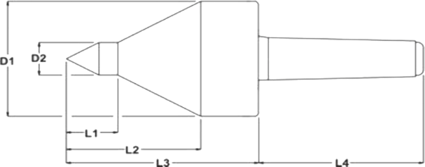

# **PIPER TOOLS AUSTRALIA PTY LTD**

# **2025 COUNTERSINKS**



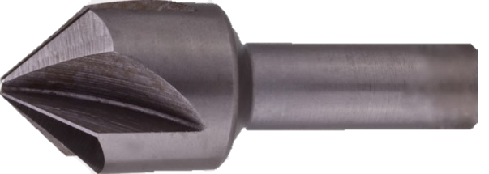

|  |  |  |  |  |  |  |  |  |
| --- | --- | --- | --- | --- | --- | --- | --- | --- |
| 90° 4 Flute Countersink | | | |  | 82° 4 Flute Countersink | | | |
| PART No. | Max Dia. | Shank Dia. | Price |  | Part No. | Max Dia. | Shank Dia. | Price |
| CS90-260 | .260" | .200" |  |  | CS82-260 | .260" | .200" |  |
| CS90-323 | .323" | .250" |  |  | CS82-323 | .323" | .250" |  |
| CS90-385 | .385" | .250" |  |  | CS82-385 | .385" | .250" |  |
| CS90-510 | .510" | .375" |  |  | CS82-510 | .510" | .375" |  |
| CS90-635 | .635" | .375" |  |  | CS82-635 | .635" | .375" |  |
| CS90-760 | .760" | .500" |  |  | CS82-760 | .760" | .500" |  |
| CS90-885 | .885" | .500" |  |  | CS82-885 | .885" | .500" |  |
| CS90-1010 | 1.010" | .500" |  |  | CS82-1010 | 1.010" | .500" |  |
| CS90-1260 | 1.260" | .500" |  |  | CS82-1260 | 1.260" | .500" |  |
| CS90-1510 | 1.510" | .625" |  |  | CS82-1510 | 1.510" | .625" |  |
| 60° 4 Flute Countersink | | | |  | **120° 4 Flute Countersink** | | | |
| PART No. | Max Dia. | Shank Dia. | Price |  | Part No. | Max Dia. | Shank Dia. | Price |
| CS60-260 | .260" | .200" |  |  | CS120-260 | .260" | .200" |  |
| CS60-323 | .323" | .250" |  |  | CS120-323 | .323" | .250" |  |
| CS60-385 | .385" | .250" |  |  | CS120-385 | .385" | .250" |  |
| CS60-510 | .510" | .375" |  |  | CS120-510 | .510" | .375" |  |
| CS60-635 | .635" | .375" |  |  | CS120-635 | .635" | .375" |  |
| CS60-760 | .760" | .500" |  |  | CS120-760 | .760" | .500" |  |
| CS60-885 | .885" | .500" |  |  | CS120-885 | .885" | .500" |  |
| CS60-1010 | 1.010" | .500" |  |  | CS120-1010 | 1.010" | .500" |  |
| CS60-1260 | 1.260" | .500" |  |  | CS120-1260 | 1.260" | .500" |  |
| 100° 4 Flute Countersink | | | |  |  |  |  |  |
| PART No. | Max Dia. | Shank Dia. | Price |  |  |  |  |  |
| CS100-260 | .260" | .200" |  |  |  |  |  |  |
| CS100-323 | .323" | .250" |  |  |  |  |  |  |
| CS100-385 | .385" | .250" |  |  |  |  |  |  |
| CS100-510 | .510" | .375" |  |  |  |  |  |  |
| CS100-635 | .635" | .375" |  |  |  |  |  |  |
| CS100-760 | .760" | .500" |  |  |  |  |  |  |
| CS100-885 | .885" | .500" |  |  |  |  |  |  |
| CS100-1010 | 1.010" | .500" |  |  |  |  |  |  |
| CS100-1260 | 1.260" | .500" |  |  |  |  |  |  |
|  | | | |  | **82° Cross Hole Countersink** | | | |
|  |  |  |  |  | Part No. | Max Dia. | Shank Dia. | Price |
|  |  |  |  |  | CH82-37 | 15-37mm | 14mm |  |
|  |  |  |  |  | CH82-50 | 25-50mm | 16mm |  |
|  |  |  |  |  | **90° Cross Hole Countersink** | | | |
|  |  |  |  |  | CH90-37 | 15-37mm | 14mm |  |
|  |  |  |  |  | CH90-50 | 25-50mm | 16mm |  |
|  |  |  |  |  |  |  |  |  |
|  |  |  |  |  |  |  |  |  |
|  |  |  |  |  |  |  |  |  |